**EXPERIMENT 3: OUTPUT**

**CHI SQUARE TEST:**

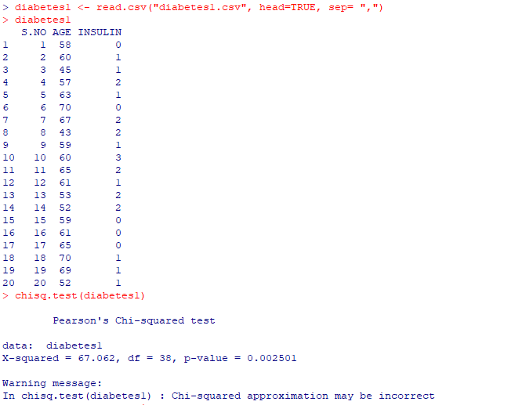

**MIN MAX NORMALIZATION:**

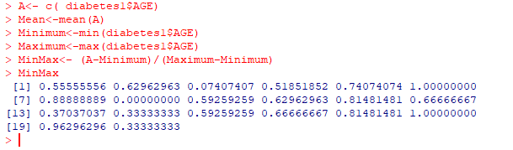

**Z SCORE NORMALIZATION:**

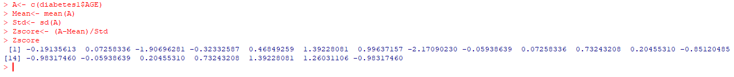

**DECIMAL SCALING NORMALIZATION:**

